Scene | Story board | Models | Length | Camera Setting | Reference
01 | 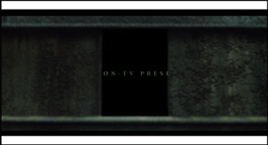 | Stone gate | 3s | Straight Zoom in | https://www.xinpianchang.com/a11649313?from=search_post
02 | 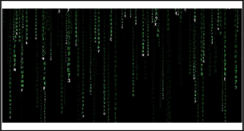 | #Coding background  #Name in the middle | 6s | No  camera movement
03 | 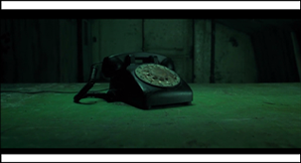 | - Telephone  - Stone ground  - Backgorund | 5s | The lens goes up from the last scene  (fade out in black) | https://www.xinpianchang.com/a11649313?from=search_post
04 | 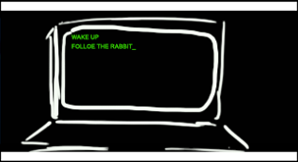 | - Computer  - Keyboard  - Table  - Some small objects if available (Papers, book or pen around the table, looks a bit mess)  - Dark Room(black background, only a table and computer) | 4s | The lens goes up from the last scene, then moves forward though the screen  (Next Scene fade in)
05 | 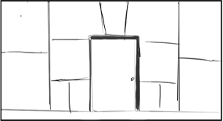 | - Mirror room  - Door in the middle | 6s | Camera hold, no movement. After lights behind the door appear,  Camera zoom in through the bright light | [00:23] https://www.xinpianchang.com/a11649313?from=search_post
06 | 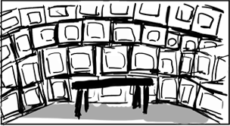 | - Pills  - TV  - Table  - Door in the middle (Same door like the Scene 5) | 3s | Camera Zoom in a bit. | 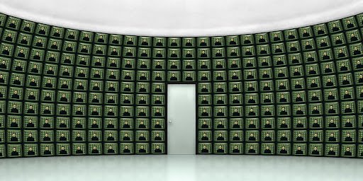
07 | 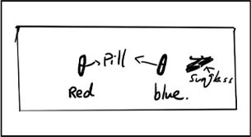 | - Pills  - Table  - tv | 5s | The camera moves forward,then rotates downward, facing the pills on the table vertically, completely symmetrical, and then zooms in according to the music like fast forward
08 | 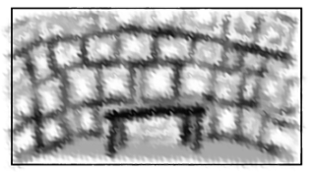 |  | 3s
09 | 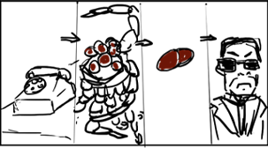  3-4 scene quickly appear in the screen, each scene shows up 2 second or less. | - Doors road  - Robot  - Pills  - Sunglasses | 5s | Camera stay in the middle and zoom in a bit.
10 |   Blue and red pills rising up from the bottom | - Blue and red Pills | 3s | Camera stay in the middle. No movement | [00:03]  https://www.youtube.com/watch?v=iY1QHpp6iEE
11 | 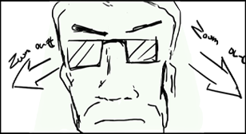 | - Agent Smith(Character) | 2s | Camera start at the character’s face and quick zoom out
12 | 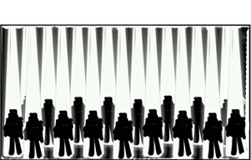  Lights open from the front to back | - Lots of Agent Smith(Character) | 4s
13 |   3-4 scene quickly appear in the screen, each scene shows up 2 second or less. | - Office Lights  - Robot  - Pills  - TV Room | 5s | Camera rotating from the first scene to the last. Feels like dizzy and get lost in these places. | [00:20-00:23]  https://www.youtube.com/watch?v=iY1QHpp6iEE
14 | 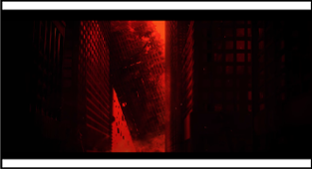  Green filter_building is falling down and be destroyed | - Buildings  - FX | 5s | Camera zoom out a bit, softly and slowly | [00:24]  https://www.youtube.com/watch?v=iY1QHpp6iEE
15 | 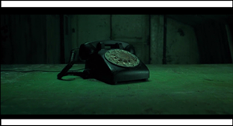 | - Telephone | 2s | Camera zoom in

